Laptop Request Service Catalogue Item in ServiceNow

Project Overview
Employees in the organization need a quick and efficient way to request laptops for official use.
Currently, the process is manual — involving email requests and IT team follow-ups — which causes delays, missing data, and poor tracking.
To overcome this, this project focuses on creating an automated Service Catalogue item in ServiceNow that allows employees to request laptops easily. The system will include:
- Dynamic form behaviour (fields change based on user input)
- Clear guidance and instructions
- Form reset option
- Automated workflow for approval and fulfillment
- Change tracking for governance and deployment
This automation reduces manual errors, improves user experience, and enhances IT governance.

IDEATION PHASE
Objective:
- Identify the main challenges in the existing laptop request process and explore how ServiceNow can solve them.
Activities:
- Discussed issues faced by employees during laptop requests (time delays, lack of tracking).
- Brainstormed automation solutions within ServiceNow’s capabilities.
- Explored using Service Catalogue, UI Policies, and Flow Designer for automation.
- Decided to implement a reset option to help users correct mistakes without refreshing the page.
- Proposed audit tracking using system logs for governance.
Outcomes:
- Defined project goal and scope clearly.
- Selected ServiceNow Catalogue Item Creation as the main solution.

Project Planning Phase
Objective:
- Plan the project workflow, responsibilities, and timelines.
Steps:
Define Scope:
- Automate laptop requests with a dynamic form.
- Enable approval workflow.
- Ensure governance tracking.
Assign Roles:
- Developer: Create catalogue item and scripts.
- Tester: Conduct performance and user testing.
- Approver: Validate workflow and deployment.
Timeline:
- Week 1: Requirement Gathering
- Week 2: Catalogue Item Creation
- Week 3: Workflow Configuration
- Week 4: Testing and Deployment
Governance:
- Track all configuration changes using update sets.
- Use version control for deployment between environments.
Deliverables:
- Project Plan Document
- Workflow Schedule
- Stakeholder Approval

Requirement Analysis Phase

Functional Requirements:
Feature | Description
Catalogue Item | Create a new item titled “Laptop Request” under IT Services
Fields | Employee Name, Department, Laptop Type, Justification, Manager Approval
Dynamic Fields | Laptop models shown based on Department
Form Reset | Reset button to clear all fields
Workflow | Manager approval → IT fulfillment → Completion notification
Notifications | Email alerts to requester and approver
Tracking | Log all requests with timestamps for auditing

Non-Functional Requirements:
- The form should load within 3 seconds.
- Follow ServiceNow UI14 theme for consistency.
- Maintain high data accuracy and zero manual handling.

Project Design Phase
UI/UX Design:
- Employee Details
- Laptop Selection
- Approval Information
- Each field includes help text for clarity.
- Dynamic behaviour managed using UI Policies and Client Scripts.
Workflow Design:
- Created using Flow Designer:
- Request submitted
- Manager approval (automated email sent)
- IT fulfillment task created
- Notification sent to user on completion
Governance & Version Control:
- Changes tracked through Update Sets.
- Deployment between Dev → Test → Prod environments managed by Change Control.
Tools Used:
- ServiceNow Platform
- Flow Designer
- Catalogue Builder
- UI Policies and Client Scripts

Implementation Steps
- Navigate to Service Catalogue → Maintain Items → New
- Name the catalogue item: Laptop Request
- Add variables: Employee Name, Department, Laptop Type, Justification.
- Configure UI Policies for dynamic field visibility.
- Add a Reset button using a client script:
function onClickReset() {
g_form.clearValue('laptop_type');
g_form.clearValue('justification');
g_form.clearMessages();
}

Design workflow in Flow Designer:
- Approval task to Manager
- Fulfillment task to IT Support
- Notifications on approval/rejection
- Publish and test the catalogue item.

Performance Testing Phase
Objective:
- Ensure the system is fast, reliable, and meets all user requirements.

Tests Conducted:
Test Type | Description | Result
Form Load Test | Verified load time under multiple users | Passed (2.3 sec)
Dynamic Field Test | Checked visibility rules based on department | Passed
Workflow Test | Tested approval and notification process | Passed
Reset Function Test | Verified reset clears all fields instantly | Passed
Audit Log Test | Confirmed all changes are tracked | Passed

User Acceptance Testing (UAT):
- Conducted with 5 employee users.
- Feedback: Form is simple, fast, and intuitive.
Results & Outcome
- Reduced laptop request processing time by 60%.
- Improved data accuracy and eliminated manual follow-ups.
- Added transparency and traceability with audit logs.
- Enhanced employee experience through automation and dynamic behaviour.

Tools & Technologies Used
- ServiceNow Platform
- Service Catalogue Designer
- Flow Designer
- Client Scripts
- UI Policies
- Email Notifications
- Update Sets

Conclusion
- The Laptop Request Service Catalogue Item simplifies and automates the process of laptop allocation in an organization.
By introducing dynamic fields, reset functionality, and workflow automation, it saves time, ensures data accuracy, and maintains governance.
This project demonstrates how ServiceNow’s automation capabilities can improve efficiency and user satisfaction in enterprise IT operations.
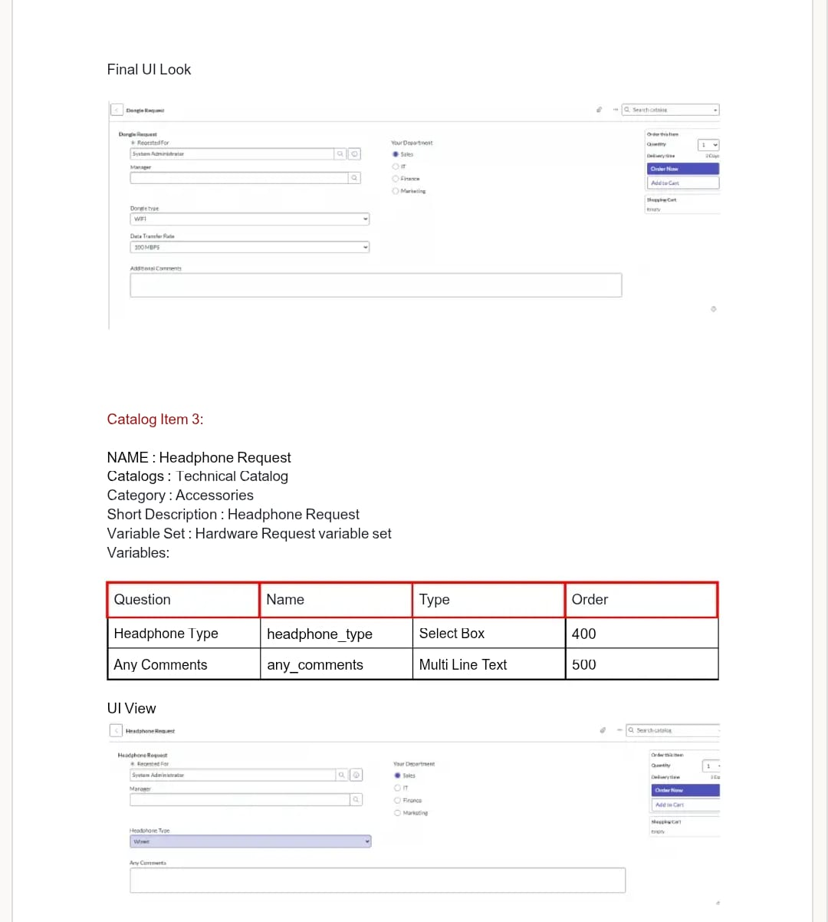
These are the procedures involved in this project

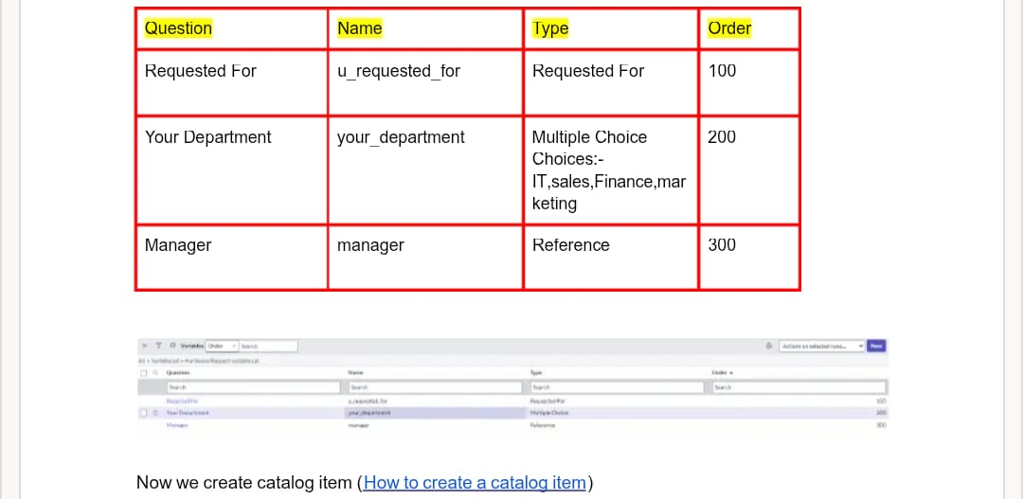

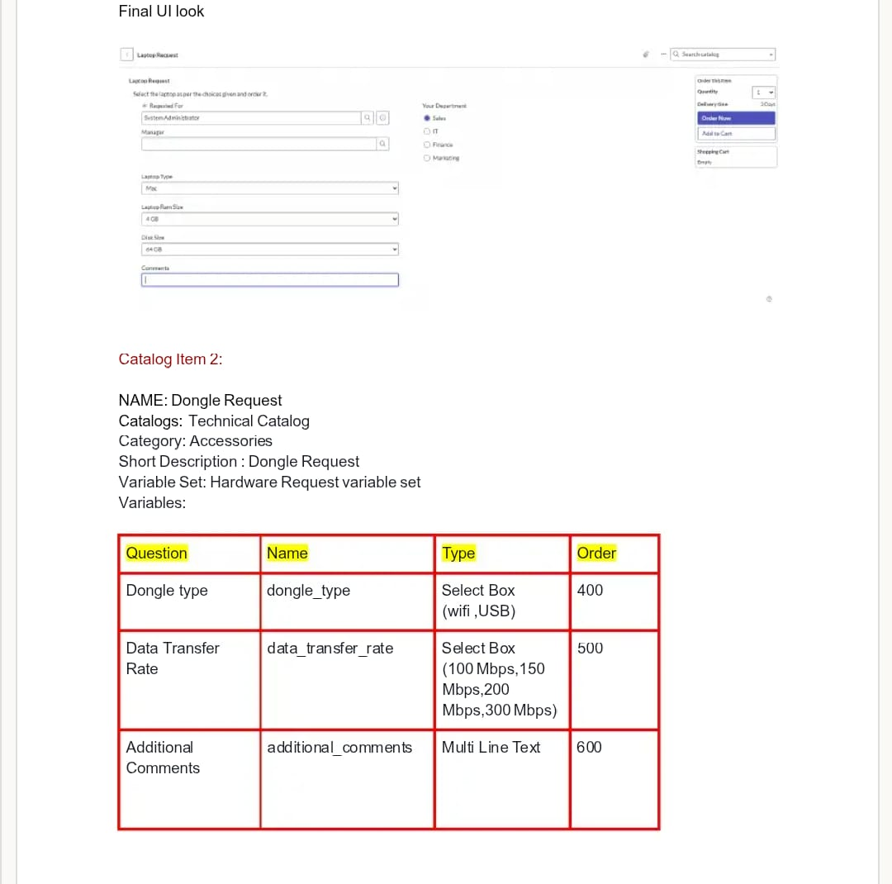

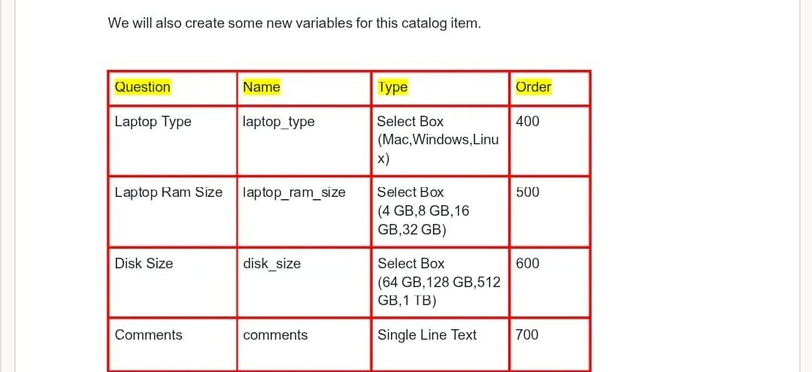

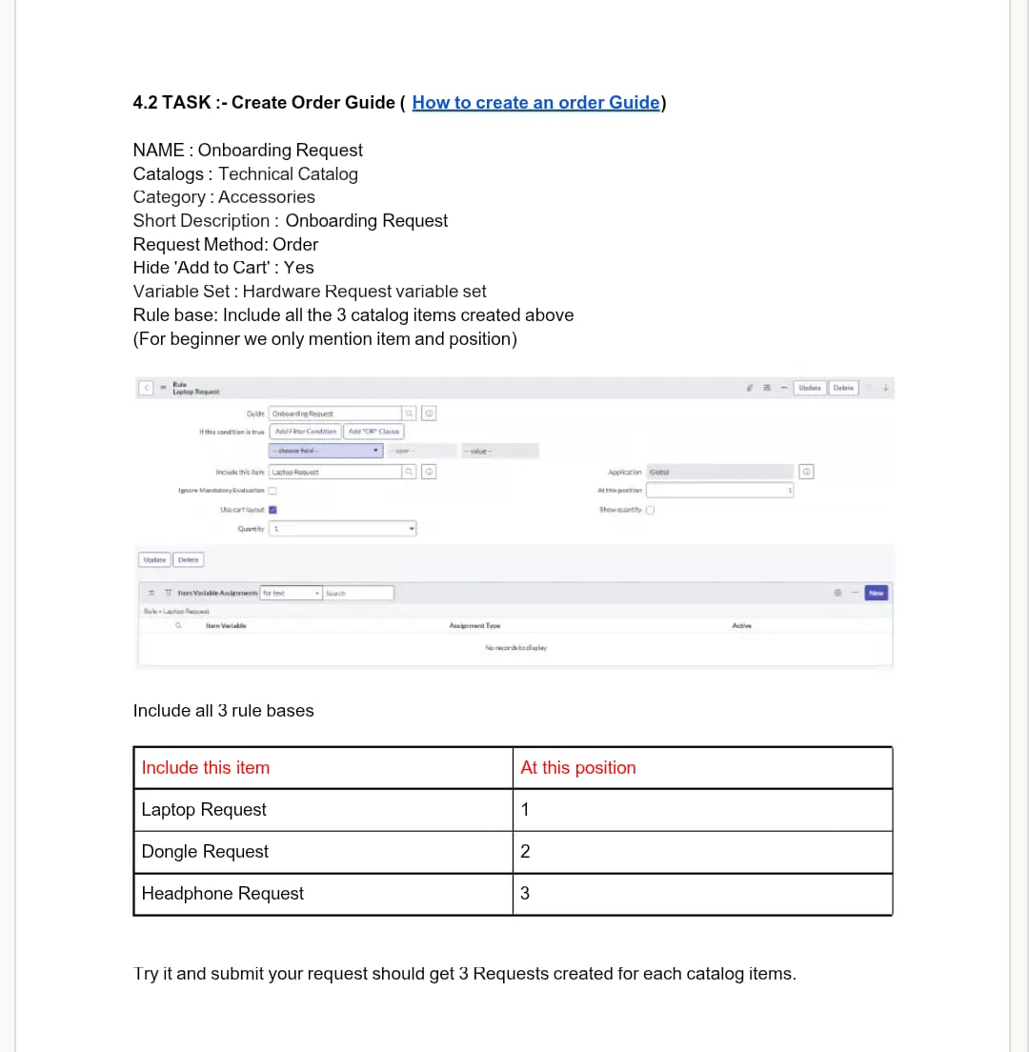

Submitted by,
- S. Adlin (961222243001)
- B. Rahul (961222243018)
- A. Steve aaron (961222243025)
- R. Siva sakthi (961222243024)

